ETHICS IN SOCIAL NETWORKS

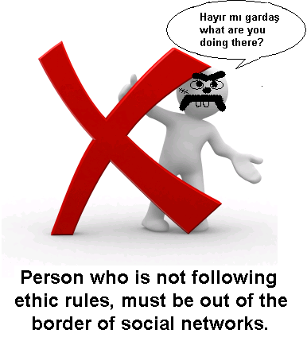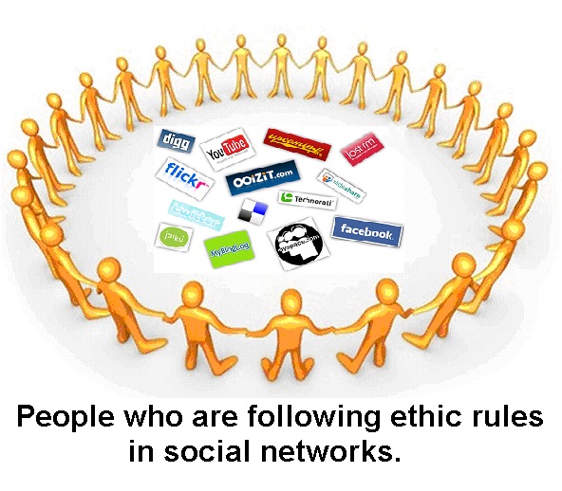

ETHICAL BEHAVIOUR
TO AVOID LOSING YOUR RESPECT
CTE-536 Computer Teaching Methods - I

Ömer Cüce

